the order of beauty  
*c o d e x*

/

f i b o n a c c i

xn = xn-1 + xn-2  
*(each number is the sum of the previous two numbers)*  
  
0, 1, 1, 2, 3, 5, 8, 13, 21, 34, 55, 89, 144, 233, 377, 610, 987, 1597, 2584, 4181, 6765 …

/

p h i

the ratio of any two successive Fibonacci numbers is very close to the golden ratio, approx. 1.618034… φ *p h i*

“the golden ratio” ~ in mathematics, two quantities are in the golden ratio if their ratio is the same ad the ratio of their sum to the larger of the two quantities

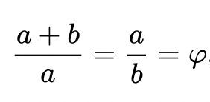

“divine proportion” : Luca Pacioli  
used by architects and artists, e.g. Le Corbusier and Salvador Dalí

also: the twenty-first letter of the Greek alphabet

/

h u m a n g e s t a t i o n

*e m b r y o g e n e s i s*

o v u l a t i o n

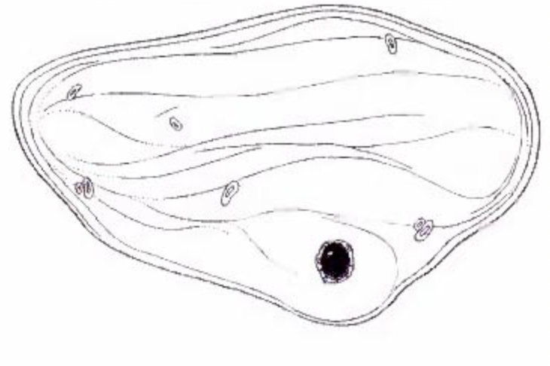

c o n c e p t i o n – f e r t i l i z a t i o n – z y g o t e ( d a y o n e )

fusion of egg and sperm to form a diploid zygote

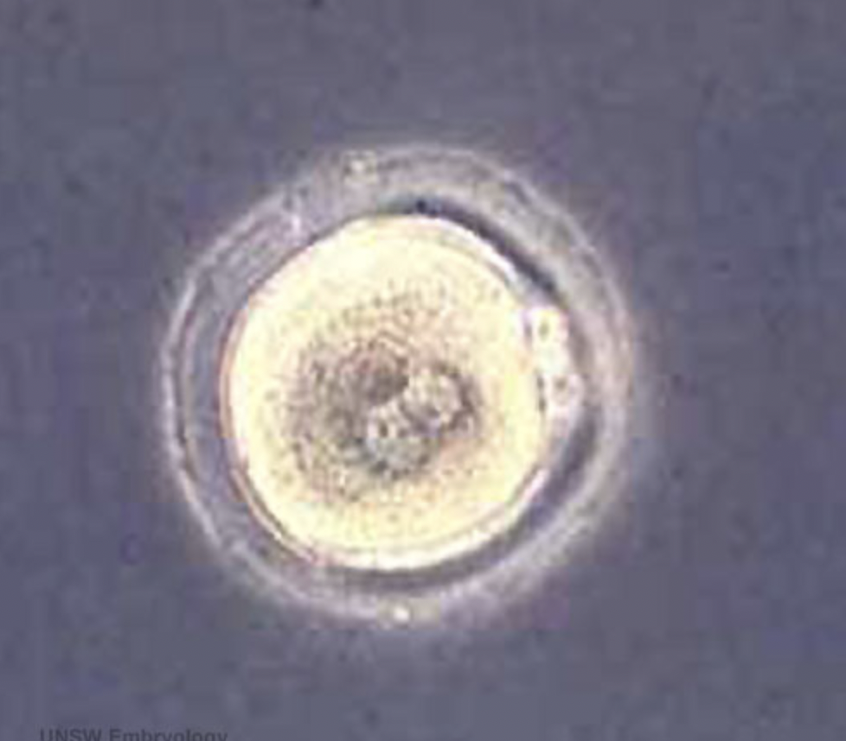

m o r u l a ~ b l a s t o c y s t ( d a y t w o a n d t h r e e )  
  
early stage in post-fertilization development when cell rapidly mitotically divide to produce a solid mass of cells (12-15 cells) with a “mulberry” appearance ~ followed by formation of a cavity in cellular mass = blastocyst (Greek, blastos ~ sprot + cystos = cavity), inner cell mass that will form the entire embryo and is the source of true embryonic stem cells capable of forming all cell types within the embryo

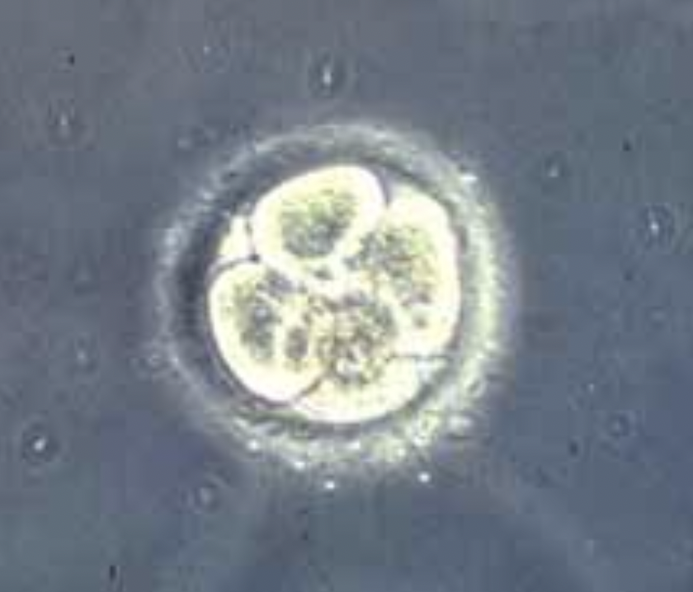

b l a s t o c y s t h a t c h i n g ( d a y f o u r a n d f i v e )

blastocyst hatches out of the protective zona pellucida ~ allows for increased growth, access to uterine nutrient secretions and blastpcyst adhesion to the uterine lining

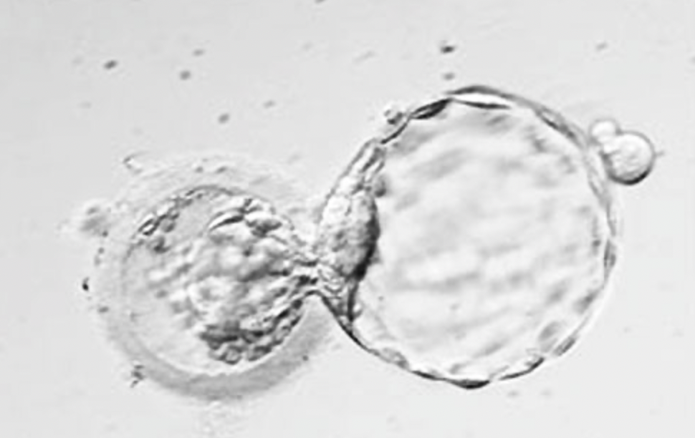

a d p l a n t a t i o n ~ i m p l a n t a t i o n ( d a y s i x s e v e n e i g h t … )

the process of attachment and invasion of the uterus endometrium by blastocyst

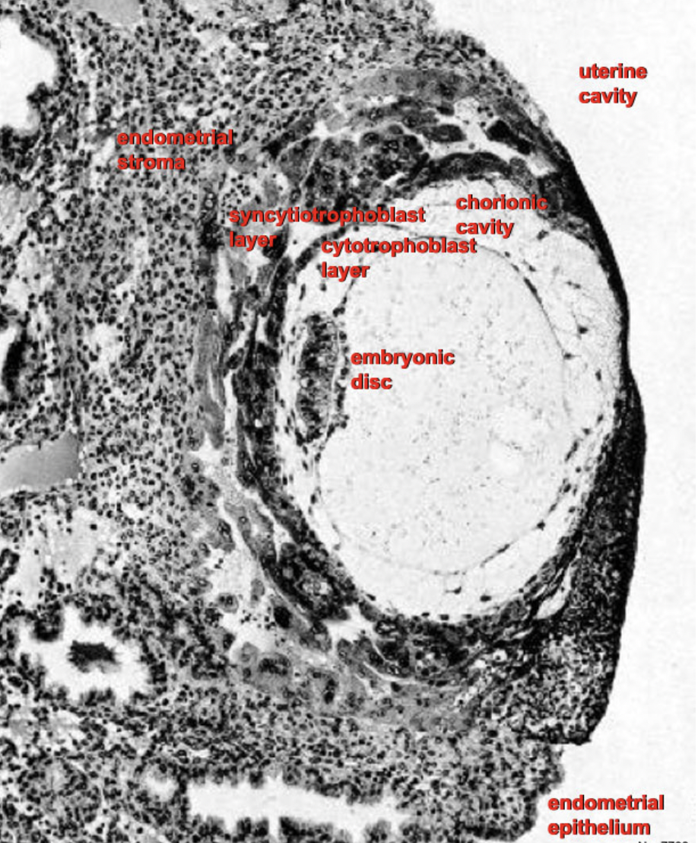

g a s t r u l a t i o n ( d a y s i x t e e n )

the formation of the gut (Greek, gastrula ~ gut), embryo has 3 layers: ectoderm, mesoderm, endoderm

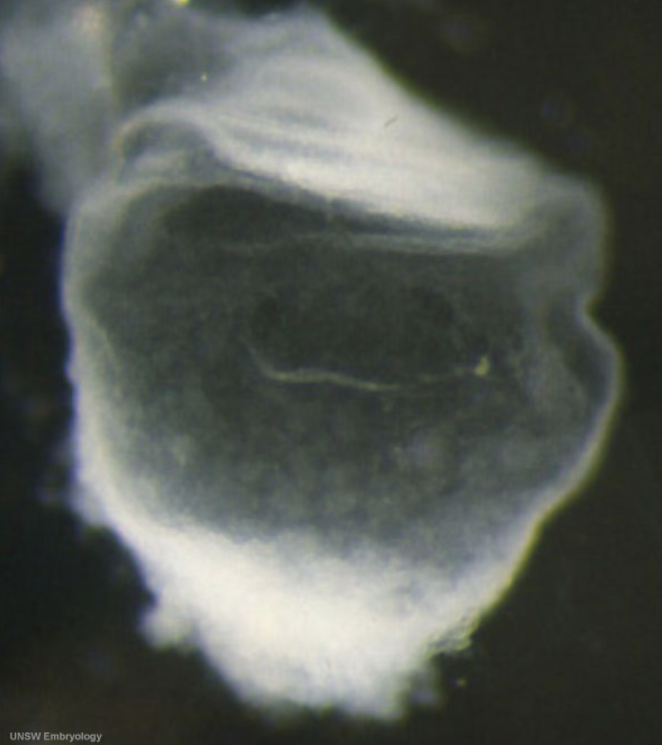

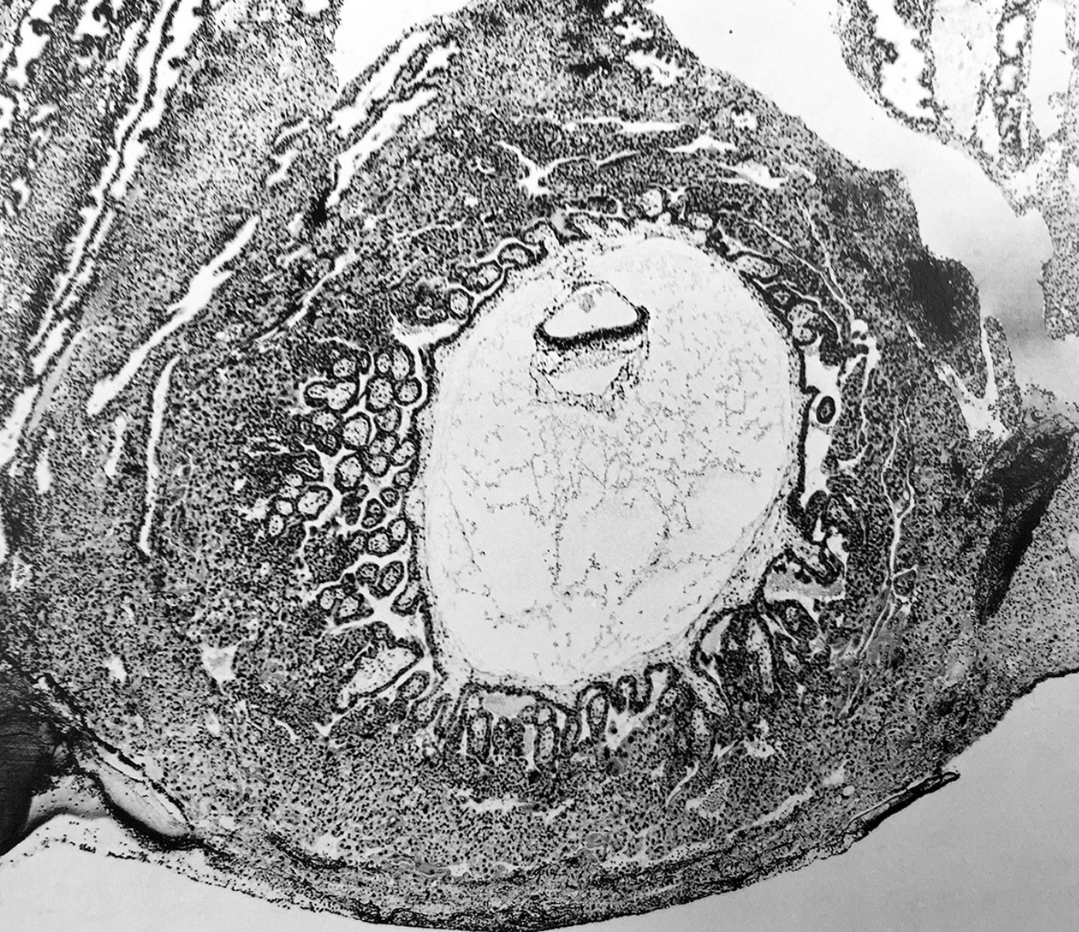

n e u r o g e n e s i s ~ c a r d i o g e n e s i s

( d a y e i g h t e e n ~ )

neural groove and folds are first seen, three main divisions of the brain form, neural crest takes shape, week 3 begins as paired heart tubes, neural crest differentiation, neural flate folded to a neural groove

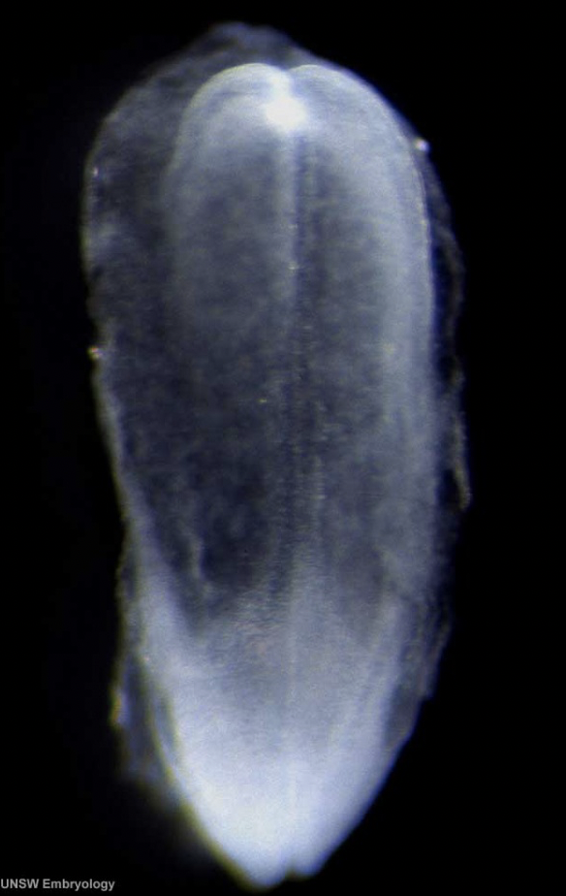

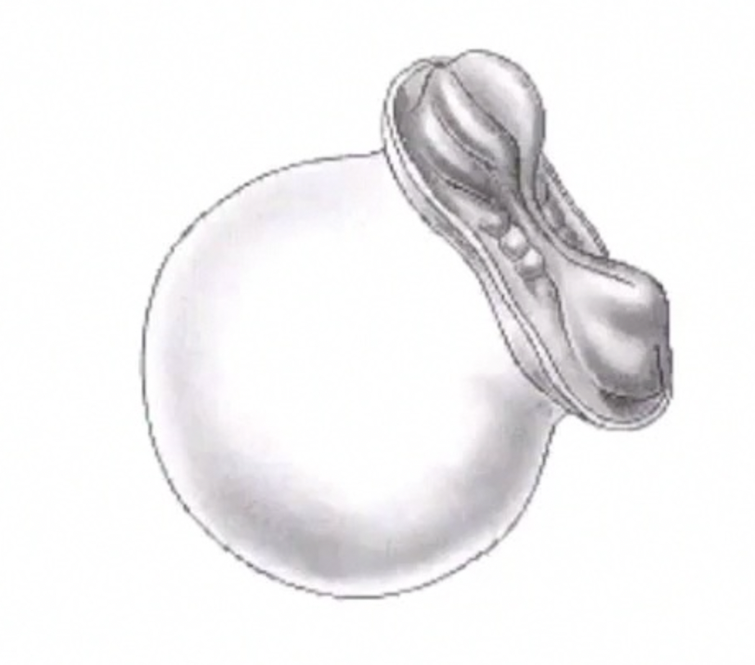

h e a r t b e g i n s t o b e a t ( d a y t w e n t y t w o / t h r e e )

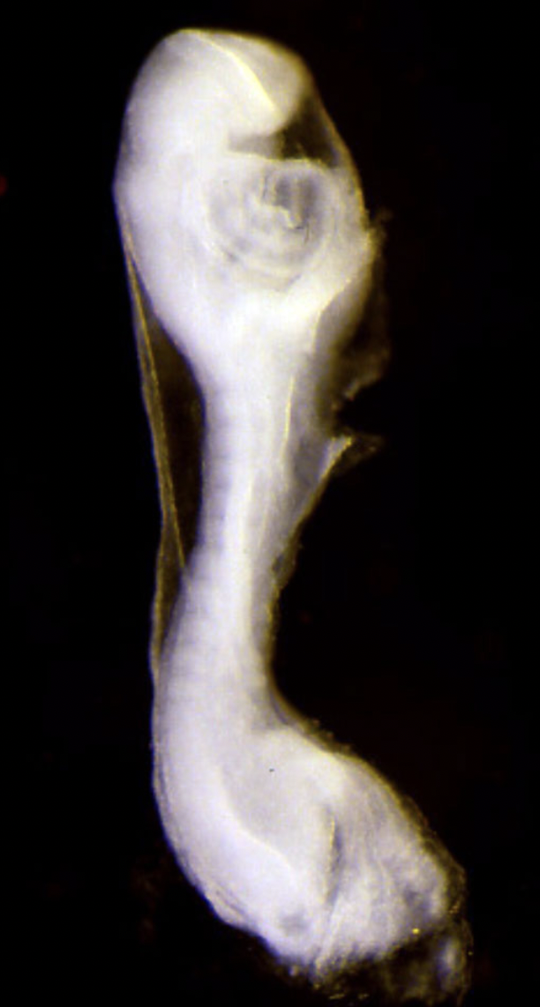

d e v e l o p m e n t o f o r g a n s a n d o r g a n s y s t e m s

( 3 r d – 8 t h w e e k )

blood

heart & circulatory system

digestive system

respiratory system

urinary system

reproductive system

integumentary system (skin)

nervous system

d e v e l o p m e n t o f p h y s i c a l f e a t u r e s

( 3 r d – 8 t h w e e k )

ears

eyes

limbs

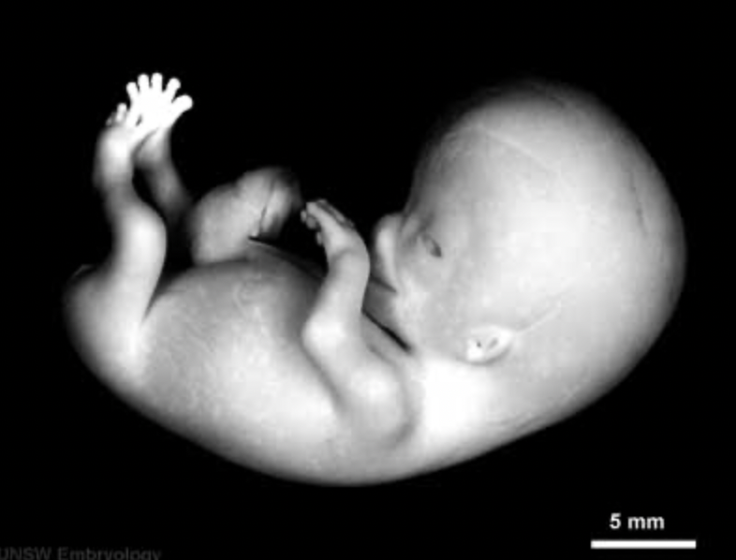

~ f i r s t t r i m e s t e r

*f e t a l d e v e l o p m e n t*

( 1 0 t h w e e k o f g e s t a t i o n / 8 t h w e e k o f d e v e l o p m e n t t o b i r t h )

cognitive development

brain activity is first detected at the end of week 5 of gestation, synapses do not begin to form until week 17 ~ neural connections between the sensory cortex and thalamus develop as early as 24 weeks’ gestational age, but the first evidence of their function does not occur until around 30 weeks, when minimal consciousness, dreaming and the ability to feel pain emerges

s e c o n d t r i m e s t e r

week 14 : head is erect, arms and legs are developed, eyes begin moving, ear are close to final position, sucking motions

week 16 : baby might begin to hear

week 18 : all organs and structures have been formed, a period of simple growth begins, respiratory movements occur, fetus movements can be felt

week 20 : nails and hair grows, lowest limit of viability, increased muscle development  
week 22 : further lung development, baby is regularly sleeping and napping

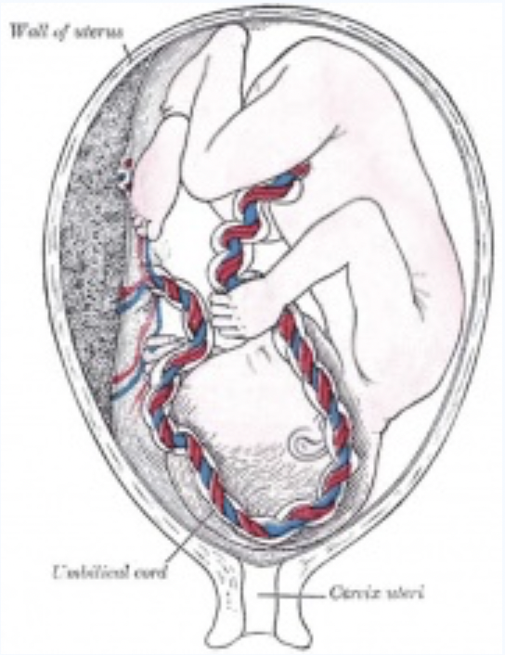

t h i r d t r i m e s t e r

week 28 : eyes partially open  
week 29 : baby kicks and stretches  
week 30 : hair grows

week 31 : rapid weight gain begins  
week 32 : baby practices breathing  
week 33 : baby detects light  
week 34 : fingernails grow  
by week 36 : baby takes up most of the amniotic sac  
week 37 : might turn head down…

*b i r t h*

*